1.
First of all we should download openssl dlls and put it into Total Commander working directory.

Without it we receive this error when we will try to turn on “SSL/TLS” check box into dialogue window that configure parameters of connection.
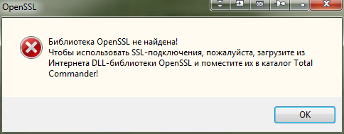

To download libraries use thils link.
https://code.google.com/p/openssl-for-windows/

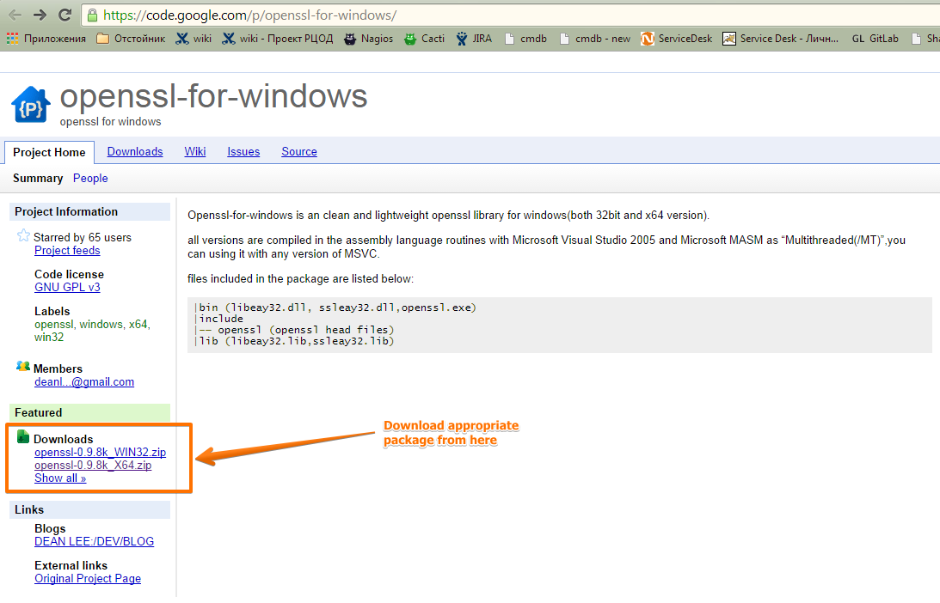

Here is direct link for x64 Windows platform.
https://code.google.com/p/openssl-for-windows/downloads/detail?name=openssl-0.9.8k_X64.zip

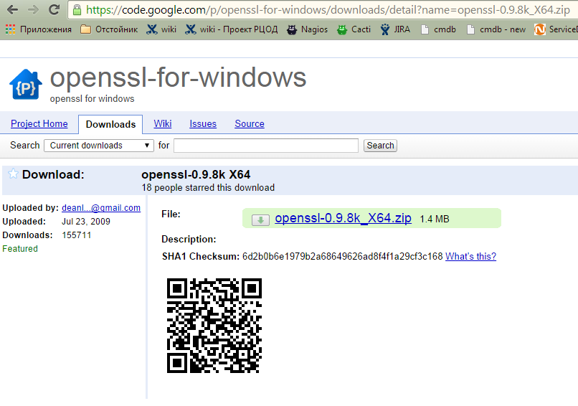
Download it.


2.
Next step is extract downloaded libraries to working directory of Total Commander.

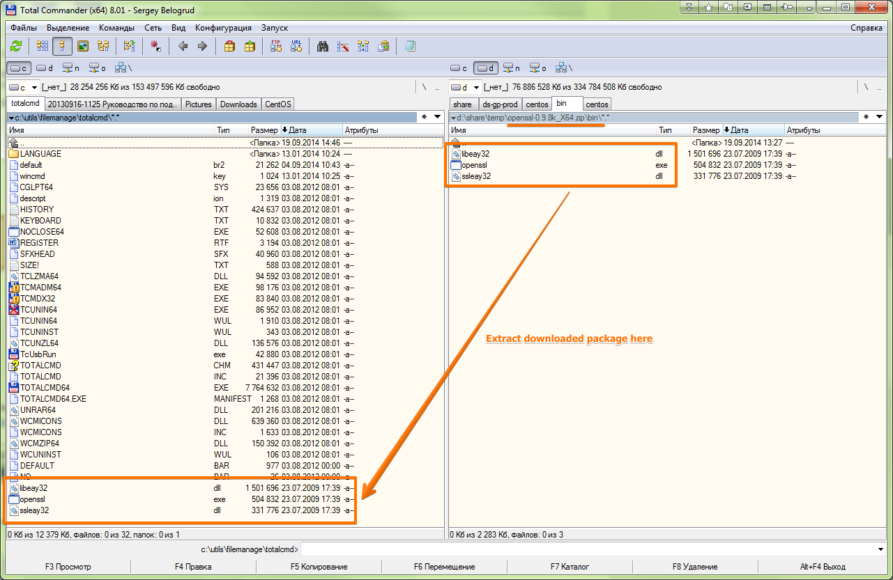

3.
Here is how to configure connection.

